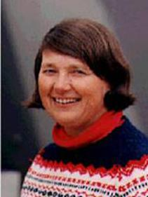

Suzanne Mahlburg Kay
William & Katherine Snee Professor of Geological Sciences Emeritus
Earth and Atmospheric Sciences
3140 Snee Hall
607/255-4701
smk16@cornell.edu
Back to Directory

Biography
Kay received a Ph.D. at Brown University and spent a year as a postdoctoral fellow and assistant professor at the University of California at Los Angeles before coming to Cornell as a post-doc in 1976. She was subsequently a research associate, senior research associate, associate professor and full professor at Cornell before becoming the William and Katherine Snee Professor of Geological Sciences in 2007. She is also a senior research associate of the IDEAN Institute of Andean studies and an honorary professor at the University of Buenos Aires, Argentina. Kay was previously a visiting associate in petrology at the California Institute of Technology and a Fulbright fellow at the University of Buenos Aires in Argentina in 1989. Among various honors, Kay is a fellow of the Geological Society of America (GSA), a fellow of the Mineralogical Society of America, a fellow of the Society of Economic Geology, a fellow of the American Geophysical Union, an honorary foreign member of the Geological Association of Argentina, a 2015 member of the Academia Nacional de Ciencias (National Academy of Science) of Argentina and has received the GSA Distinguished Service Award, the eastern division American Association of Petroleum Geologist outstanding educator award and a University of Illinois Geology Alumni Achievement Award. Prominent activities include having been the 2013-2014 President of the Geological Society of America and a member of the council from 2001-2003 and 2012-2015, president of the GSA International Division, a member of the US National Committee for Geological Sciences of the U.S. National Research, the science editor of GSA Today, the chair of the 2006 International meeting hosted by the GSA and the Geological Association of Argentina on the "Backbone of the Americas", the International Secretary of the Geological Society of America and on the editorial boards of a number of journals. Kay has edited 4 books, has over 135 reviewed publications in journals and books, and over 560 conference proceedings along with numerous abstracts. She has an H index of 42 on ISI and of 56 on Google Scholar with > 12,000 citations.

