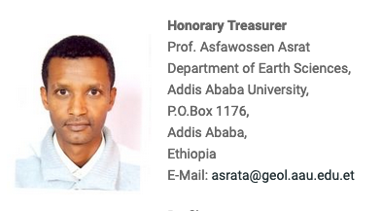

Treasurer of the Geological Society of Africa, Member of the UNESCO Global Geopark Council.

