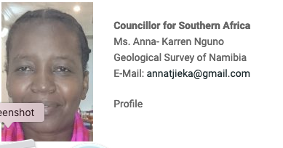

Anna is:
member of the council of the Geological Society of Africa
member of GIRAF the former IUGS geoscience information in Africa network of the IUGS commission on geoscience informatics CGI

