Presentation Title, max 16 words (NO authors or affiliations!)

Instructions
Your extended abstract should be in English, just 4 pages long including all figures, tables and references (font is 12pt Times New Roman). Section Headings are bold and the paragraphs are justified and separated by blank line. Final formatting will be made by the publisher.

Notification of acceptance is up to five days after papers submission.

Call for papers and deadlines
- Open Call for extended abstracts: March 10, 2024
- Opening registration: March 15, 2024
- Extended abstract submission deadline*: April 20, 2024
- Pre-registration deadline: May 1, 2024
- Registration and papers submission: komsne@yahoo.com

*Notification of acceptance of the extended abstract is up to five days after papers submission.

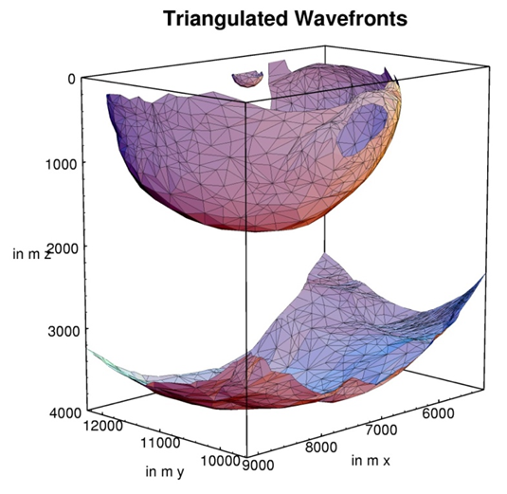
Figure 1 This is an example of a figure imported from jpeg (courtesy of Gilles Lambaré).

Examples (Optional)
Example text, please delete if you don't use it.

Conclusions
This is the first sentence of the conclusion.

Acknowledgements (Optional)
The submission deadline is 20 April 2024 (23:59 CET)!

References
This is the first sentence of the References section.

